**JOIN, RIGHT JON DAN LEFT JOIN**

1. SELECT jenis, manfaat, obat.id_apoteker FROM `obat` JOIN apoteker ON obat.id_apoteker = apoteker.id ORDER BY id_apoteker ASC;

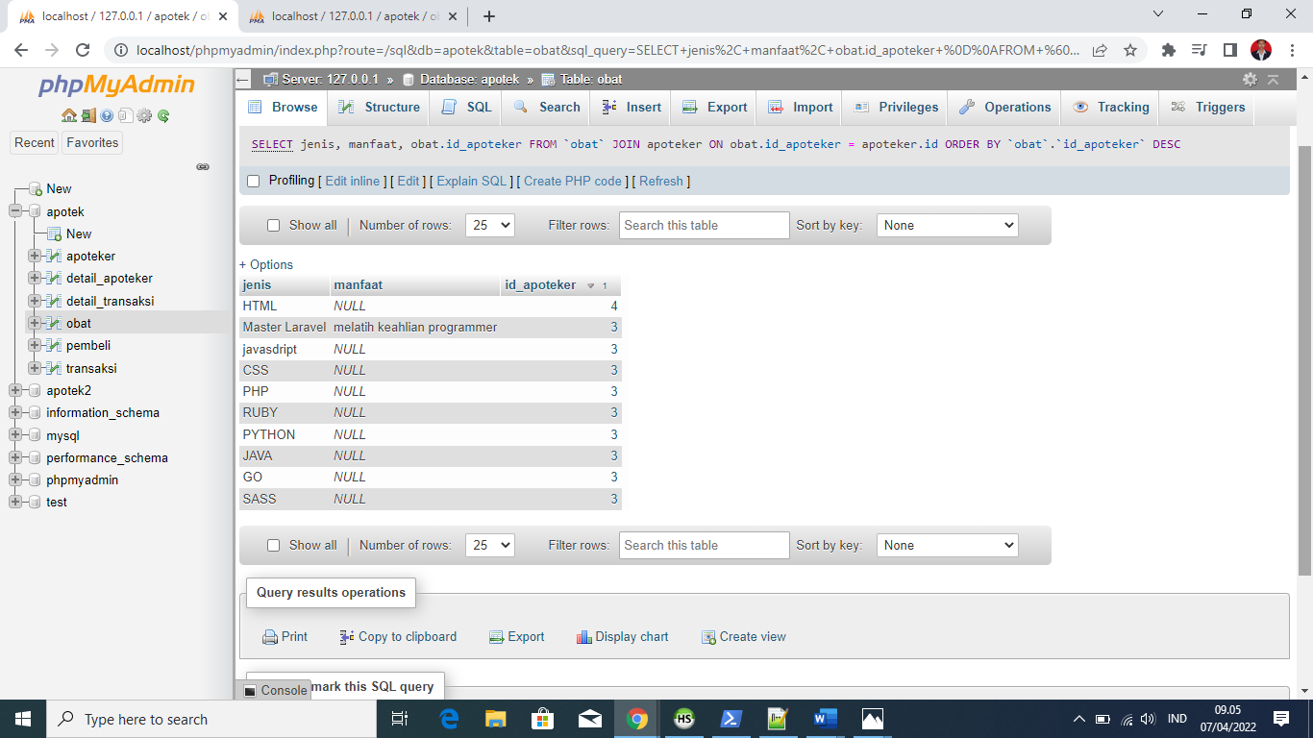

1. SELECT jenis, manfaat, obat.id_apoteker FROM `obat` RIGHT JOIN apoteker ON obat.id_apoteker = apoteker.id ORDER BY id_apoteker ASC;

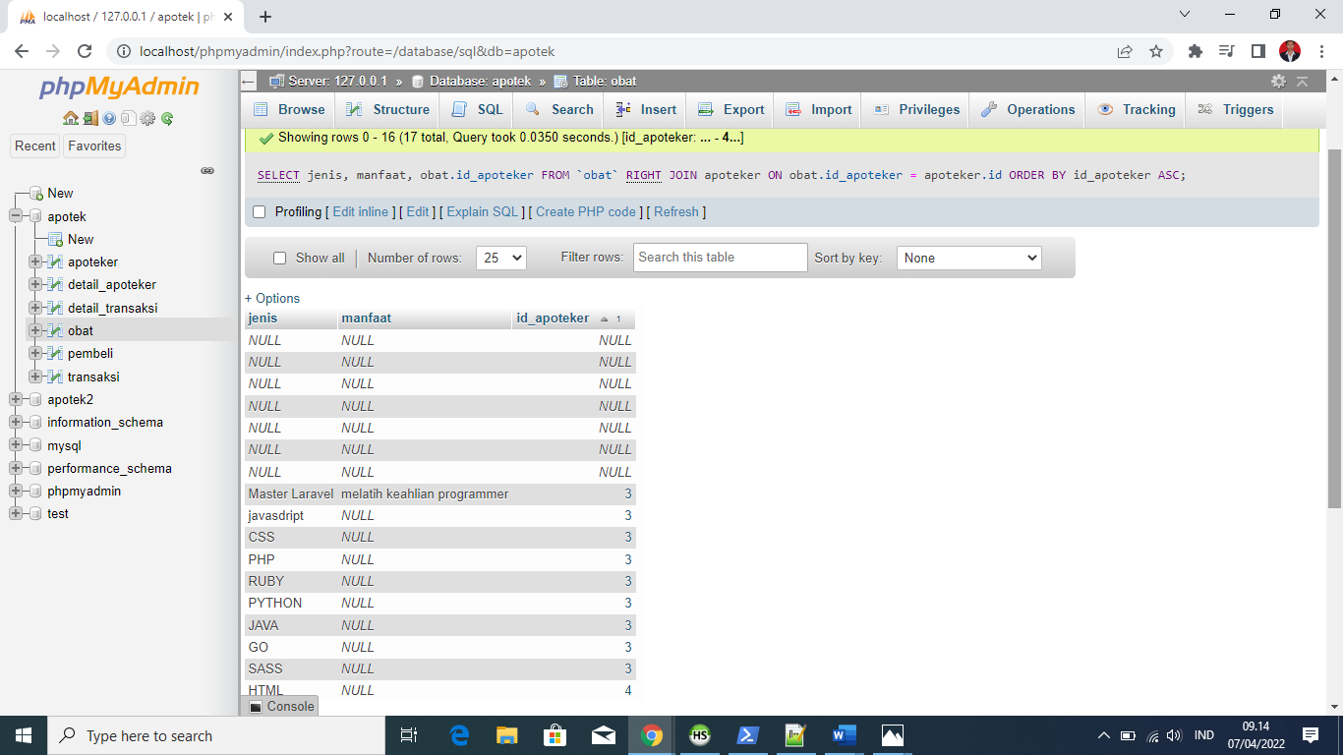

1. SELECT jenis, manfaat, obat.id_apoteker FROM `obat` LEFT JOIN apoteker ON obat.id_apoteker = apoteker.id ORDER BY id_apoteker ASC;

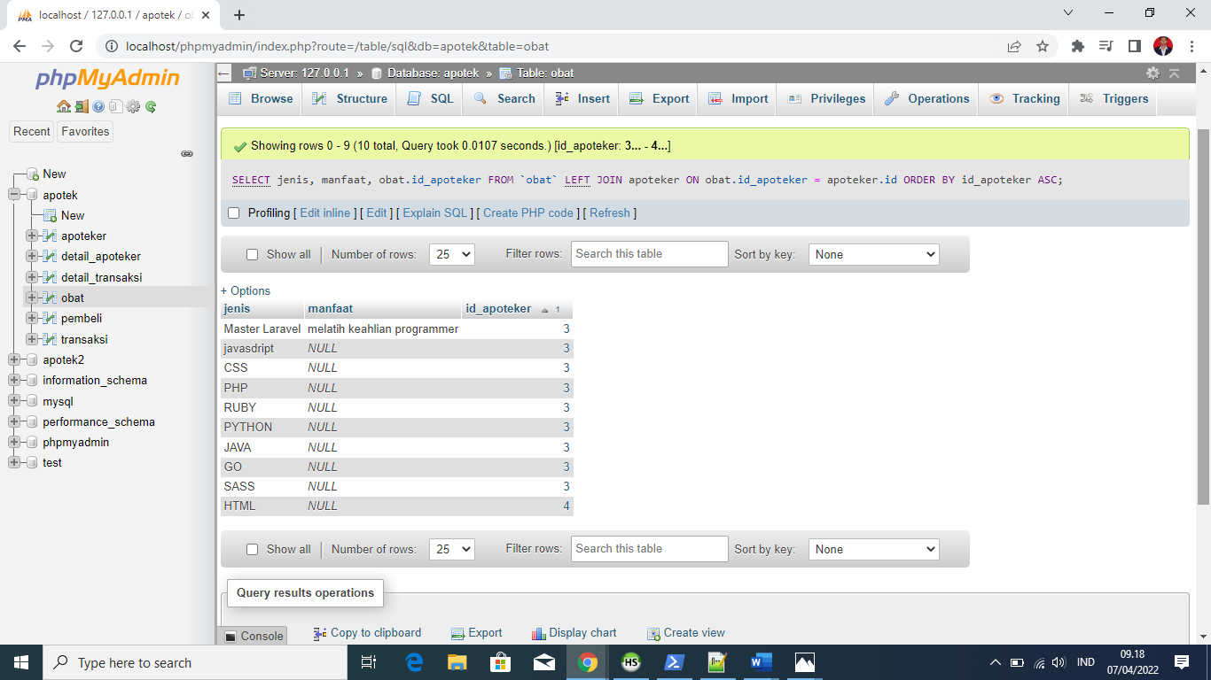

1. SELECT id_transaksi, harga FROM detail_transaksi JOIN obat ON detail_transaksi .id_obat = obat.id WHERE harga >= 10000 ORDER BY id_transaksi DESC;

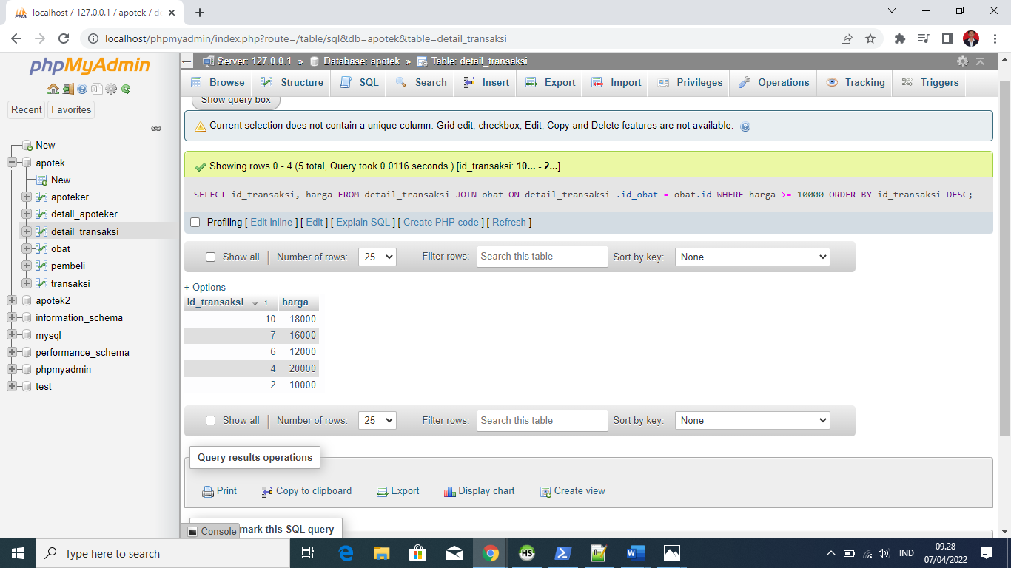

1. SELECT id_transaksi, harga FROM detail_transaksi JOIN obat ON detail_transaksi .id_obat = obat.id WHERE harga >= 10000 ORDER BY id_transaksi DESC;

